**Creating Microservices for account and loan**

**Step-1: account microservice**

* Created and downloaded a template from **springintializr**
* Created a controller package then a **getaccount.java** as a **controller** method.

**getAccount.java**

**package** com.cognizant.account.controller;

**import** org.springframework.web.bind.annotation.*;

@RestController

@RequestMapping("/accounts")

**public** **class** getAccount {

@GetMapping("/{number}")

**public** Account getAccountDetails(@PathVariable String number) {

**return** **new** Account(number, "savings", 100000);

}

**static** **class** Account {

**private** String number;

**private** String type;

**private** **double** balance;

**public** Account(String number, String type, **double** balance) {

**this**.number = number;

**this**.type = type;

**this**.balance = balance;

}

**public** String getNumber() { **return** number; }

**public** String getType() { **return** type; }

**public** **double** getBalance() { **return** balance; }

}

}

**OUTPUT;**

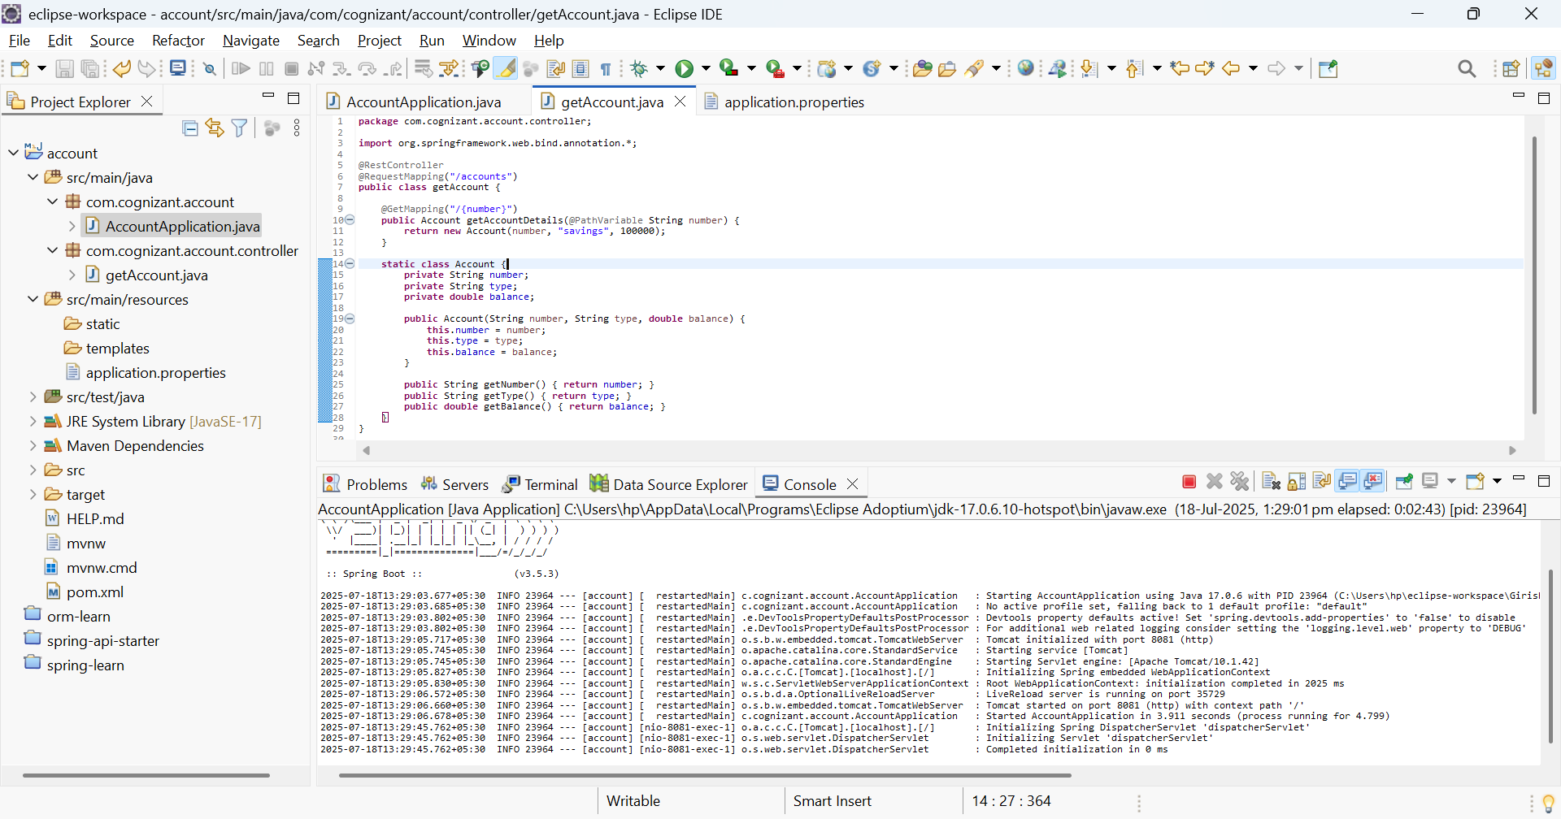

**WEBBROWSER OUTPUT**

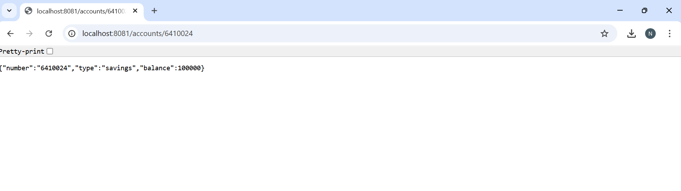

**Step-2: loans microservice**

* Created and downloaded a template from **springintializr**
* Created a controller package then a **getaccount.java** as a **controller** method.

**getLoanDetails.java**

**package** com.cognizant.loan.controller;

**import** org.springframework.web.bind.annotation.GetMapping;

**import** org.springframework.web.bind.annotation.PathVariable;

**import** org.springframework.web.bind.annotation.RequestMapping;

**import** org.springframework.web.bind.annotation.RestController;

@RestController

@RequestMapping("/loan")

**public** **class** getLoanDetails {

@GetMapping("/{number}")

**public** loan getDetails(@PathVariable String number) {

**return** **new** loan(number,"2000","18th july","250");

}

**class** loan{

String number;

String loanAmount;

String endDate;

String due;

**public** loan(String number,String Amount,String date,String due) {

**this**.number=number;

loanAmount=Amount;

endDate=date;

**this**.due=due;

System.***out***.print( "number: "+number +"Loan Amount is: "+loanAmount+" end date is :"+endDate+" due:"+due);

}

**public** String getNumber() { **return** number; }

**public** String getLoanAmount() { **return** loanAmount; }

**public** String getEndDate() { **return** endDate; }

**public** String getDue() { **return** due; }

}

}

**Output:**

